Wordpress is a no-code website builder. Low or no-coding website builders are increasingly popular, especially for e-commerce stores and personal websites. They will save the end user time and frustration and can be enhanced with plugins and easily modified for front end design with themes.

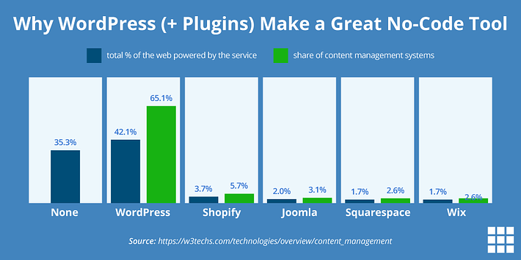

But why use WordPress in particular? This low-code content management system (CMS) has been around since 2003, and it remains one of the most famous drag and drop website platforms to this day. Many of the major websites that you visit every day are made with a WordPress back end software package.

Learn more on the WordPress site -> https://wordpress.org/

**THEMES**

A no-code website builder is a software program that interprets code visually using different templates. Usually, these take the form of drag and drop blocks that you can place wherever you choose to change a website’s look or functionality without needing HTML. Instead of having different pages of code to look at, you edit each page visually. There are hundreds of free themes to select from, many with pre-built pages, social media integration, and tutorials. You can customize the look of your website, add additional pages as needed, and start creating the structure of your website. While themes play a role in the look of your website, you can customize them further by changing colors, fonts, and layouts in your page builder.

**BLOCK EDITOR**

Most of the work done in designing a custom WordPress website comes from the Block Editor. From the images and videos to the text and contact forms, each part of your website is inserted and adjusted as a block. Ease of use means you can arrange blocks in hundreds of ways and add new blocks all the time, without coding skills. The default editor in WordPress is the Gutenberg Block Editor, but there are plugins to give you even more options.

**PLUG-INS**  
Plugins are essential to enable specific website functions. Whether you want e-commerce features or marketing tools, or to track your website’s performance, create image galleries, or anything else you can imagine, there’s often a WordPress plugin for it. Some plugins are for your entire website, while others (usually referred to as widgets) are pasted onto a page using the Block Editor. Out of the thousands of available WordPress plugins, many of the best plugins are free or offer free plans.

**NO CODING?**

Compared to coding, WordPress is easier to interpret and visualize without being a professional web designer. While coding your website from scratch does allow for the most flexibility, there are many benefits to using a no-coding website builder like the WordPress CMS:

* WordPress can accomplish many different tasks that often require multiple coding languages like HTML, CSS, PHP, and JavaScript.
* You can share access to your WordPress website to let multiple people make changes. While you can do this with code, more people can understand and edit a codeless WordPress website.
* The WordPress software itself is completely free.
* Creating websites with no-code editors is faster than coding a website from scratch. If, for example, you want to add an image, you select the image block in WordPress and upload the picture from your computer.

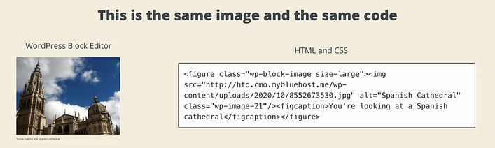

**WHAT ARE THE CODING LANGUAGES THAT ARE USED BEHIND THE SCENES OF A WORDPRESS WEBSITE?**

Just because a student does not need to learn or use coding to make websites it does not mean that understanding what they are is not a great skill. WordPress is software that is driven by a very powerful database system called MySQL. We will be learning more about databases and how websites “talk” to them to display web pages.

**HTML**

The first version of HTML was written by Tim Berners-Lee in 1993. Since then, there have been many different versions of HTML. The most widely used version throughout the 2000's was HTML 4.01, which became an official standard in December 1999. The current level of HTML is 5.

Here is a basic history of HTML -> [https://www.washington.edu/accesscomputing/webd2/student/unit1/module3/html_history.html](https://www.washington.edu/accesscomputing/webd2/student/unit1/module3/html_history.html#:~:text=The%20first%20version%20of%20HTML,HTML%20as%20an%20XML%20language)

WordPress Sites still use HTML to display contents on your browser. There are many advantages to this. One of them is that WordPress software authors make sure that the HTML code is up to date for industry standards. This page lists what the current accessibility standards are for HTML-> <https://html.spec.whatwg.org/multipage/>

One of the main standards is making sure that every person who accesses the internet is able to have the same experience no matter what browser they are using or who the person is. Disabled users require specific functionality to be able to engage with a website in the same way that other users do. Standards check to make sure those functions are in place. Web designers used to have to check changes in standards periodically to make sure their sites were up to date. As technology and the internet changes quickly this was nearly a full-time job.

Here is the source code of Liam’s homepage:

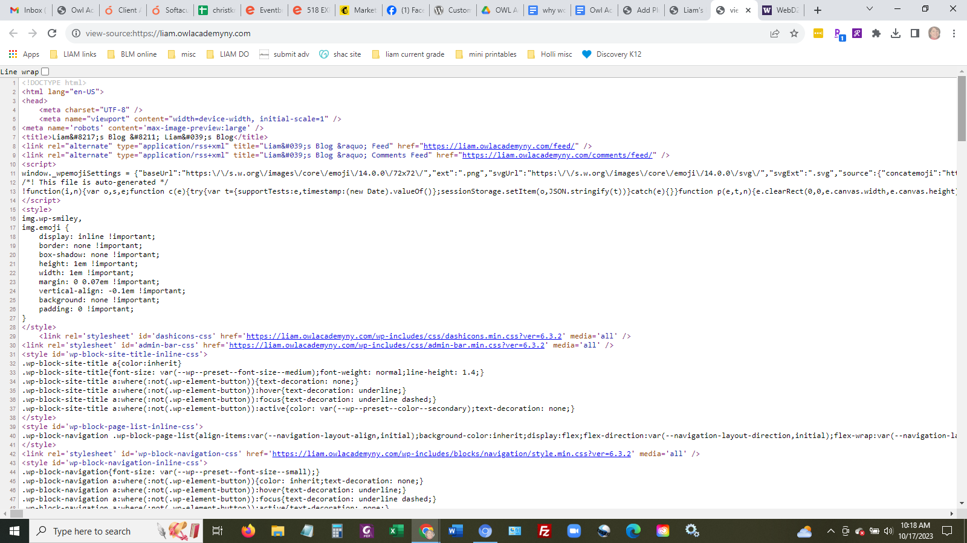

Fortunately all of this code is automatically generated by WordPress. It was not that long ago that someone would need to have a text file and type in all of these lines!

You can look at the code of any website when you are browsing the web on a computer. Just right click on a mouse and select View Source. A new tab will open with the source code.

**CSS**

Cascading style sheets is the section of code that dictates how web pages look. If you look at the source code in Liam’s home page you can see <style> functions. This is telling the website to display certain codes in a certain way. If the style codes have a lot of code lines in it then it will call (or ask the website to retrieve) a full page of code. CSS pages are called stylesheets. Here is more information about old school editing of stylesheets -> <https://www.washington.edu/accesscomputing/webd2/student/unit3/index.html>

You can edit stylesheets within the WordPress dashboard but it is not recommended. WordPress now includes a customizer for themes where you can change colors, fonts, sizes, spacing and more visual elements.

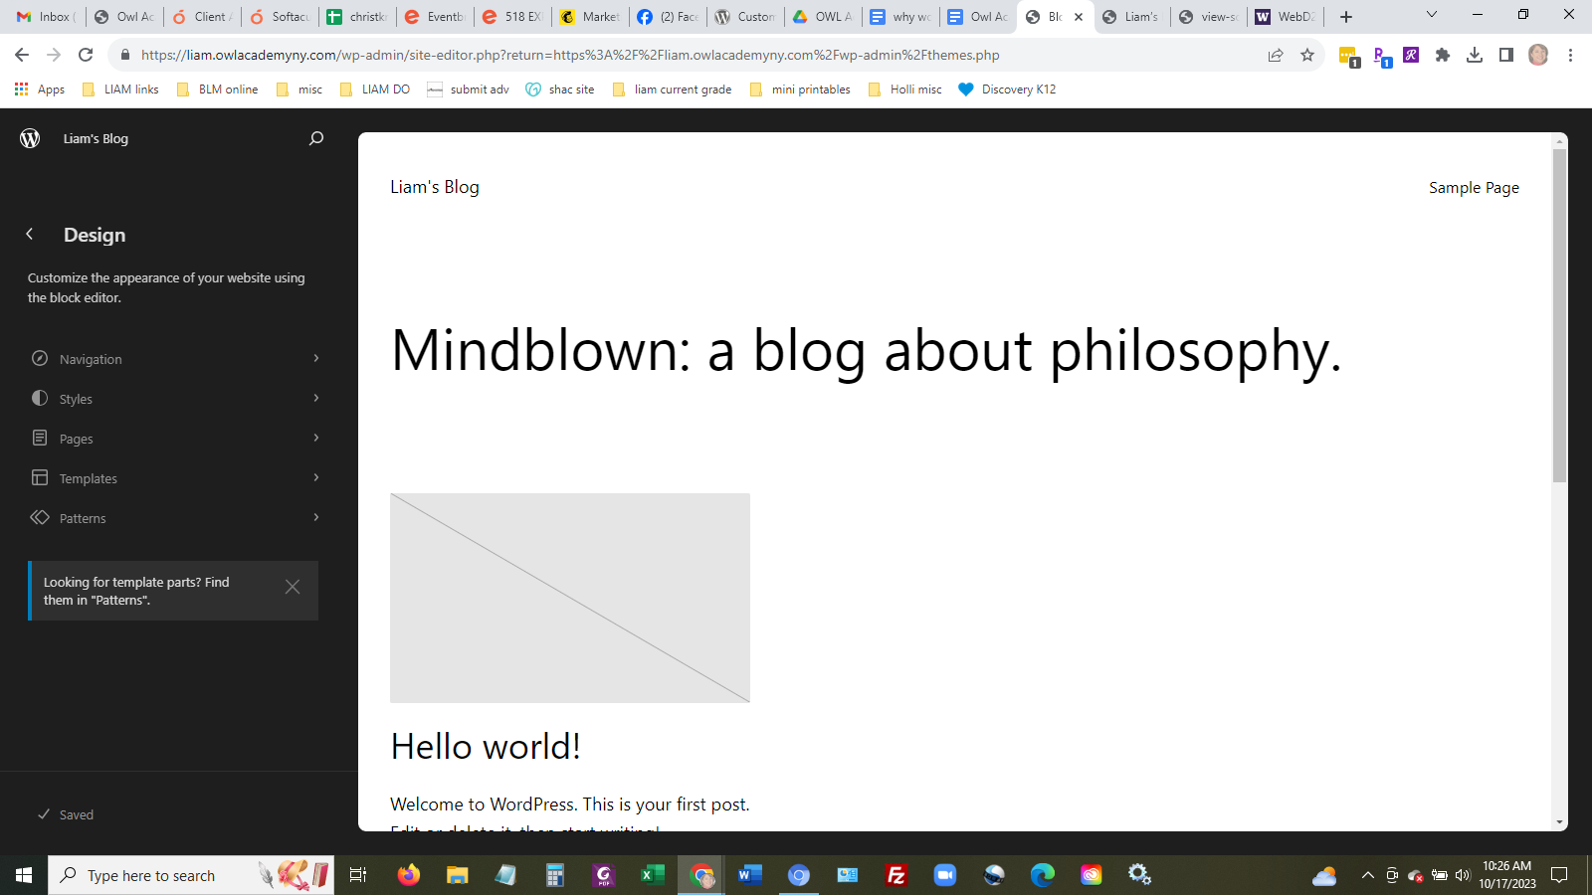

**SCRIPTING**

WordPress also runs with many scripts in the background. These are generally written in one of 2 languages - Javascript or PHP (or both!). Previously a site designer would have had to know at least a small amount of scripting languages to create a website. Now WordPress will write the scripts for you.

“Client-side scripts typically result in changes to the current page (such as sub-menus appearing, or hidden content suddenly becoming visible), whereas server-side scripts typically result in custom content being delivered to the browser when a new page is loaded. Also, client-side scripts will show up in the source code, and server-side scripts may be detectable by the filename extension (for example, .php, .asp, .aspx). Also, if the URL of a page includes variables and values separated by "&" and "=", the page is probably using server-side scripting, taking those variables and processing them before creating an HTML web page.” (<https://www.washington.edu/accesscomputing/webd2/student/unit5/module1/lesson1.html>)

Javascript is a client-side script. If you look at the code source image below you see near the top a bit of content within the <script> tags. The HTML also calls for longer Javascript files at the very bottom of the code.

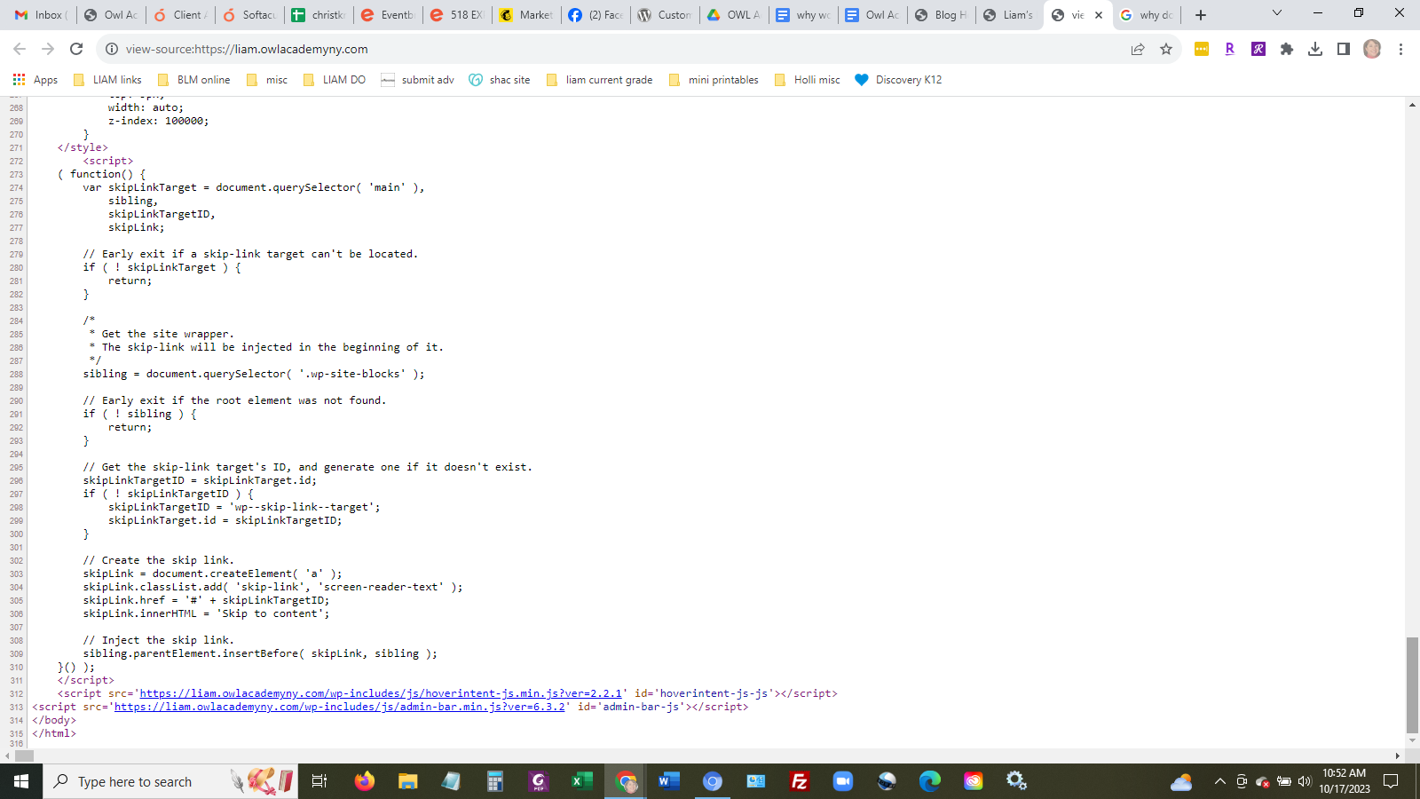

PHP is a server-side script. It is the primary way WordPress communicates with the database.You used to see website pages that had .php as their extensions. A few years ago designers realized this opened security holes for hackers. Access to PHP files is now much more hidden.

**DATABASES**

WordPress uses a MySQL database. The definition of MySQL is “MySQL is a relational database management system (RDBMS) developed by Oracle that is based on structured query language (SQL). A database is a structured collection of data. It may be anything from a simple shopping list to a picture gallery or a place to hold vast amounts of information in a corporate network.” (Oracle website)

WordPress creates, edits, modifies, and calls the database that power the WP websites. However in the control panel for the website you can do all of these things yourself. However it is not recommended! To access these databases you go to the Databases section of the control panel.

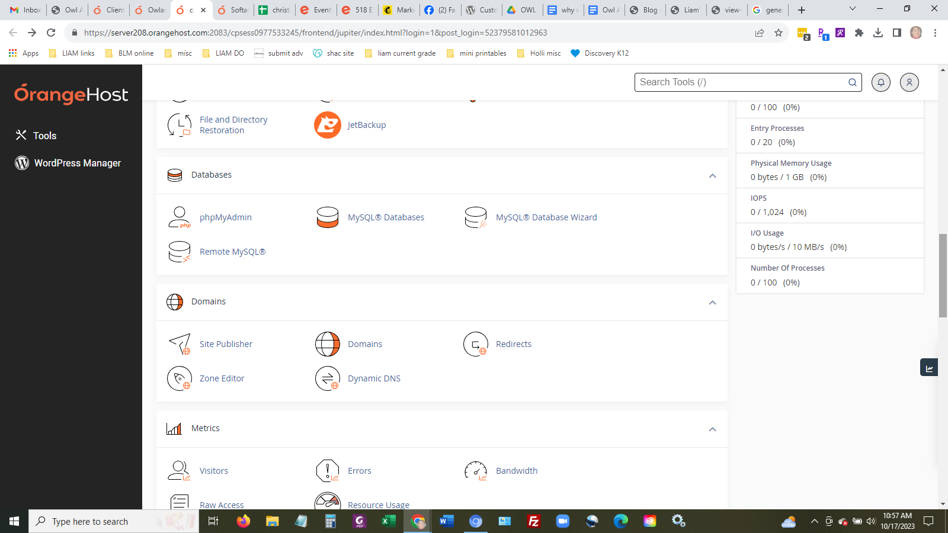

When you click phpMyAdmin you see this:

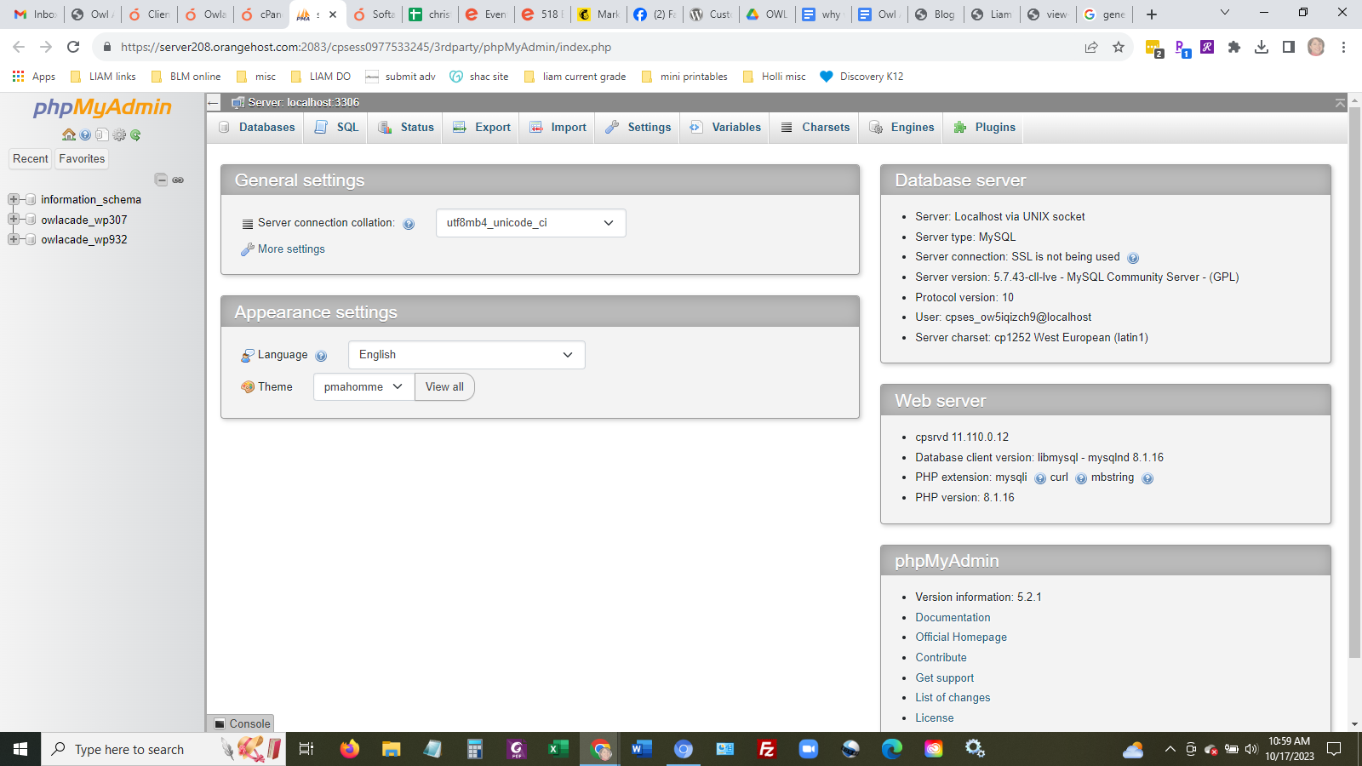

When you select a particular database (listed on the left) you see this:

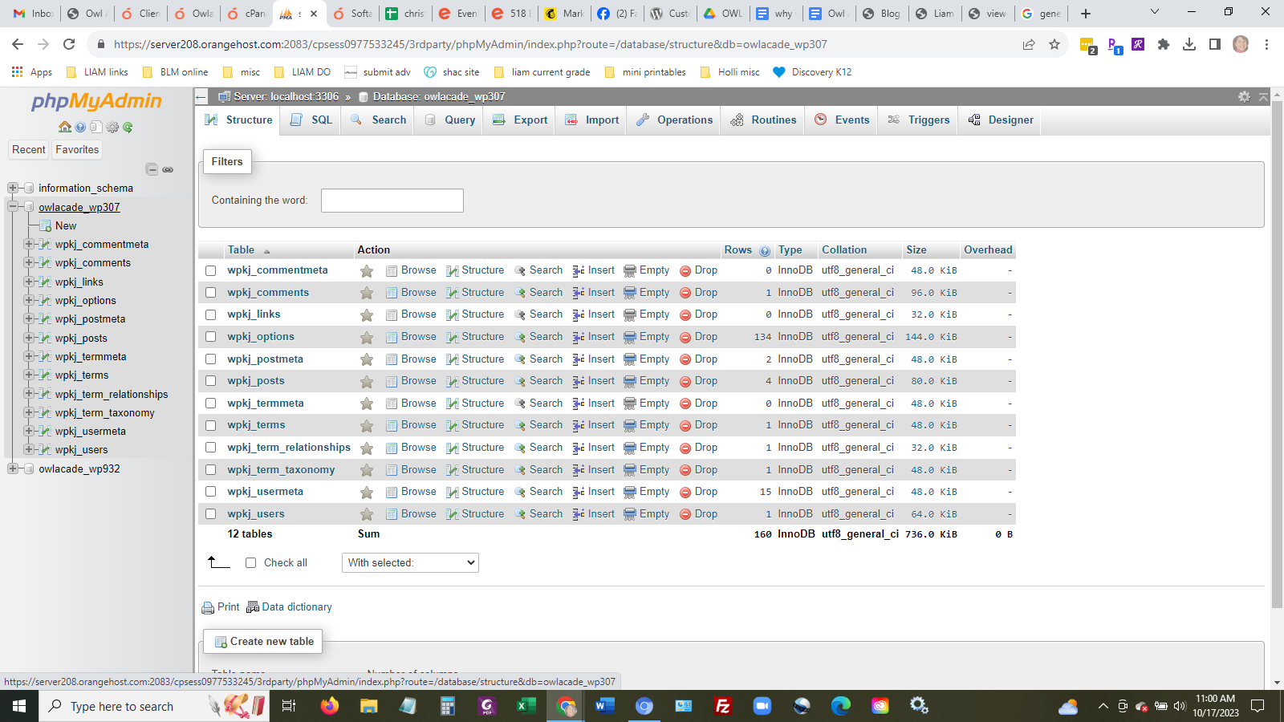

Databases are fascinating and really run the internet. Everything you do online is powered by them! Google, Amazon, Netflix - all powered by databases. It is something we can dive deeper in later.